**NEON WAVERACERS**

**By: BitBeginners**

Mawahid Abbas

Huzaifa Shabbir

Saad zafar

Hamza Naveed

**Concept:**

A racing game that takes place in a retro futuristic city with retro as well as futuristic cars and different types of events.

**Lore/Story:**

Welcome to Neon Olympus, where the old-fashioned classic cars get more love than a vintage vinyl record at a hipster cafe. In this city of sleek, futuristic skyscrapers and neon-lit streets, there's a nostalgic charm to be found in the rumble of a V8 engine and the gleam of chrome accents.

While hover cars may be the talk of the town, it's the timeless beauty of classic automobiles that steals the spotlight here. From the iconic cars of the 1960s to the elegant exotic cruisers of the 1970s, Neon Olympus is a paradise for collectors and enthusiasts who appreciate the craftsmanship and heritage of a bygone era as well as improving the classics with a little futuristic touch.

After arriving at this paradise, you encounter a group of racers, “The Neon Velocity Vanguard” who challenge you to a race in their all blacked out 90s sedans .

After dominating the competition in a slow car, you are further invited to a time trial but only after using a better car,after dominating even that, the demo ends after beating the drift trial with the chosen car made for drifting.

**Replayability:**

All events can be replayed after unlocking them through progressing through the story.

Beating All 3 events unlocks all cars.

**Systems Involved:**

Car controller

Rigid body

Camera controller

User Input system

AI system (for racers)

Music management

Event management systems (script for each type of event)

Save management

**Controls:**WASD/arrow keys for movement  
Space for handbrake

Escape to reset

Enter to start event/interact with trigger

**Car controller:**

Does Calculations depending on the user or the AI’s input and applies them to each car’s rigid bodies

**Camera Controller:**

Follows the Player car only by connecting with the GameController script.

**Ai System:**

Follows the nearest waypoint and turns towards it if it needs to.

**Music Management**

Plays music depending on a random number generation

**Event management system**

There are 3 types of events and the demo contains 1 of each, there is a race which takes place within the border of the city, there is a time trial and then followed by this there is a drift event. The player is free to play all 3 events after unlocking them.

You can even start multiple events at the same time.

**Save management**

Using PlayerPrefs class, one can save the movement of the player through the story and then load it later on after closing the game.

**Artstyle:**

80s vaporwave/synthwave inspired futuristic art style.

**Sound:**

Different car sounds for each car state of the car, idle,start,running etc. Sounds of skid,tire smoke etc along with music that matches the vibe.

**Camera:**

The game has 4 cameras which are switched by using the C key:

Close camera

Top down Camera  
A slightly tilted top down camera

Close camera (doesnt change direction)

**References:**

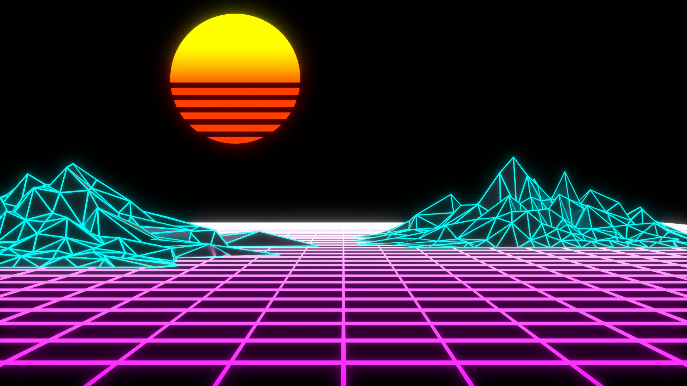

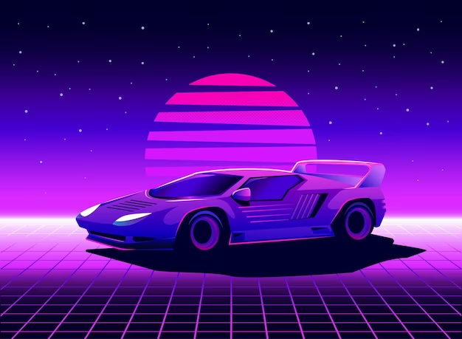

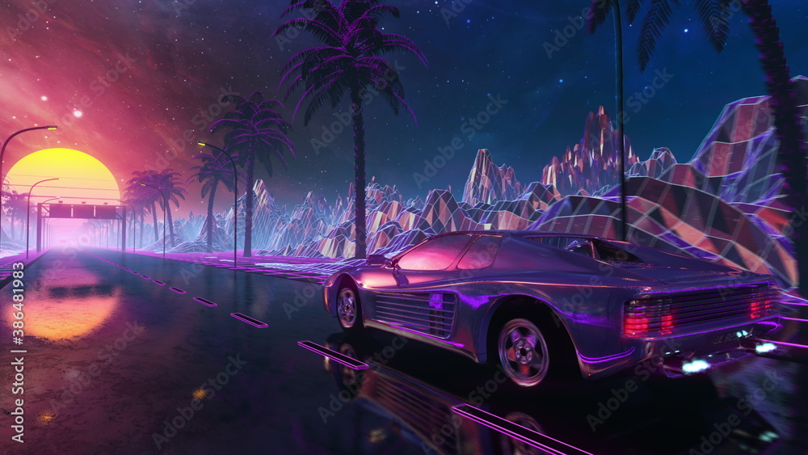

**Game ScreenShots:**

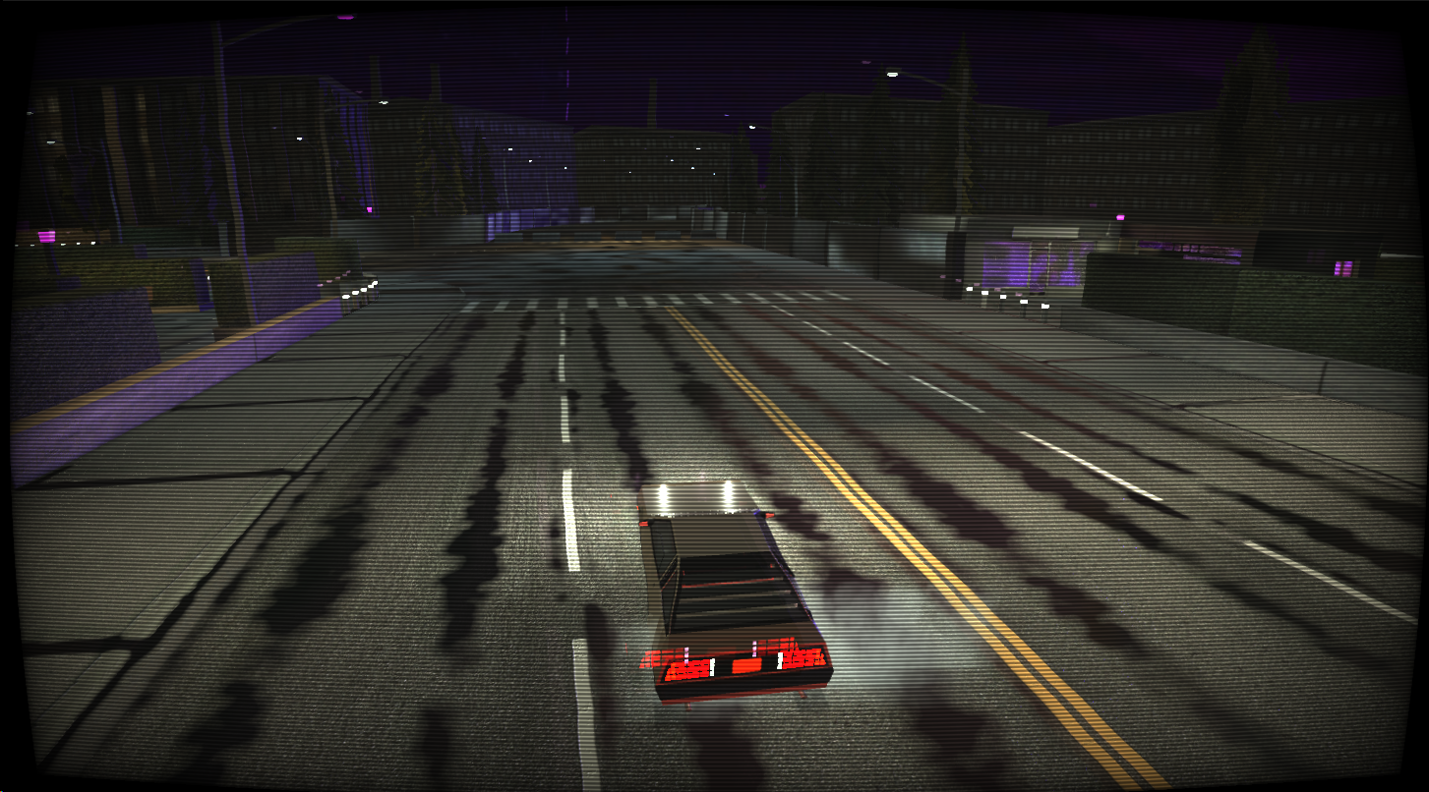

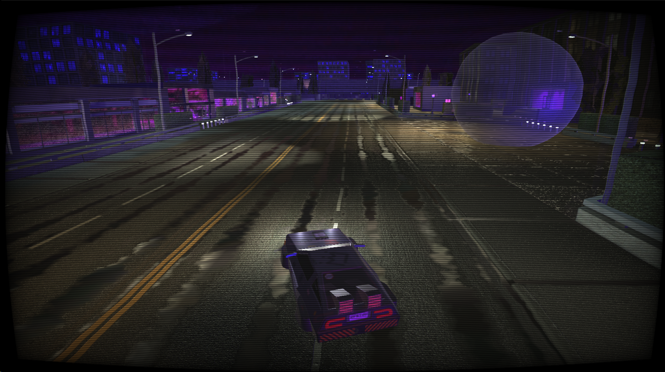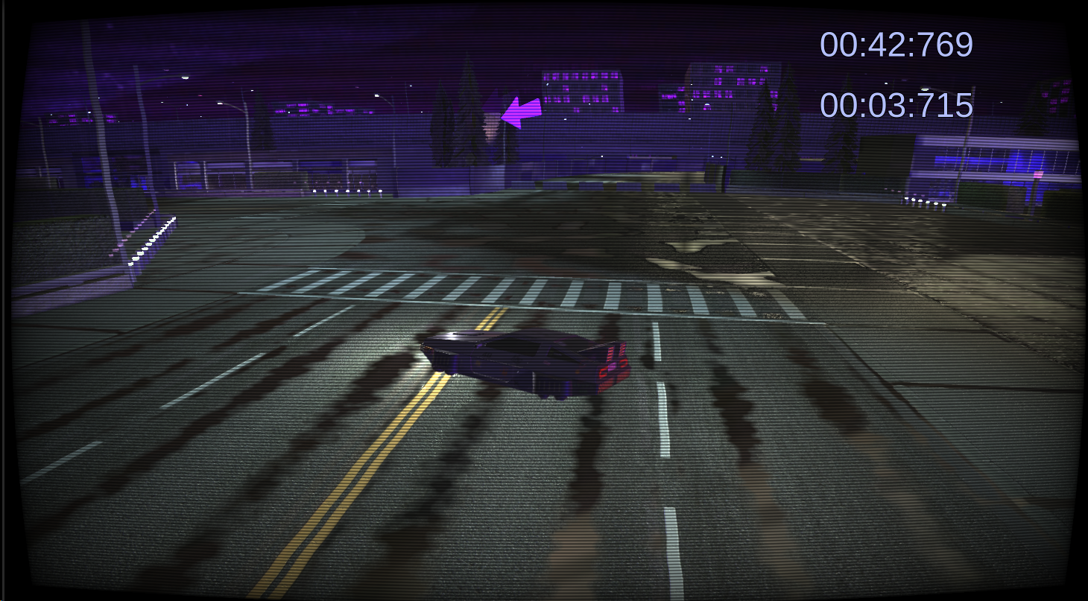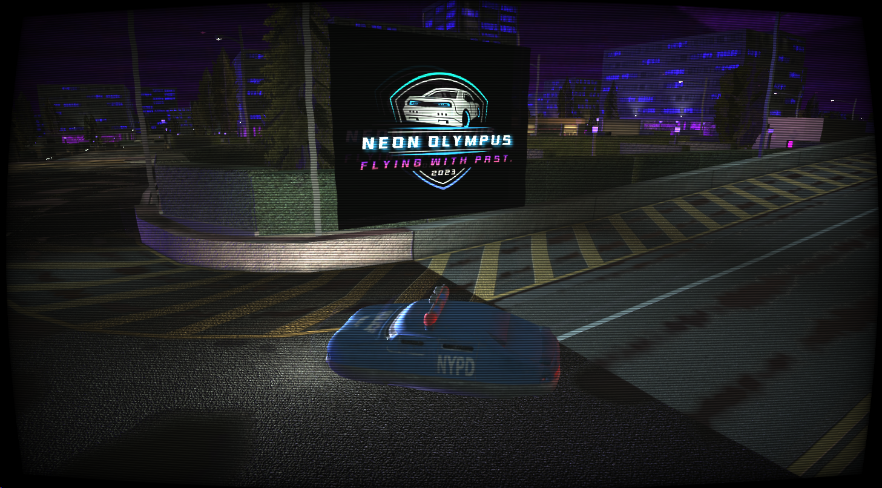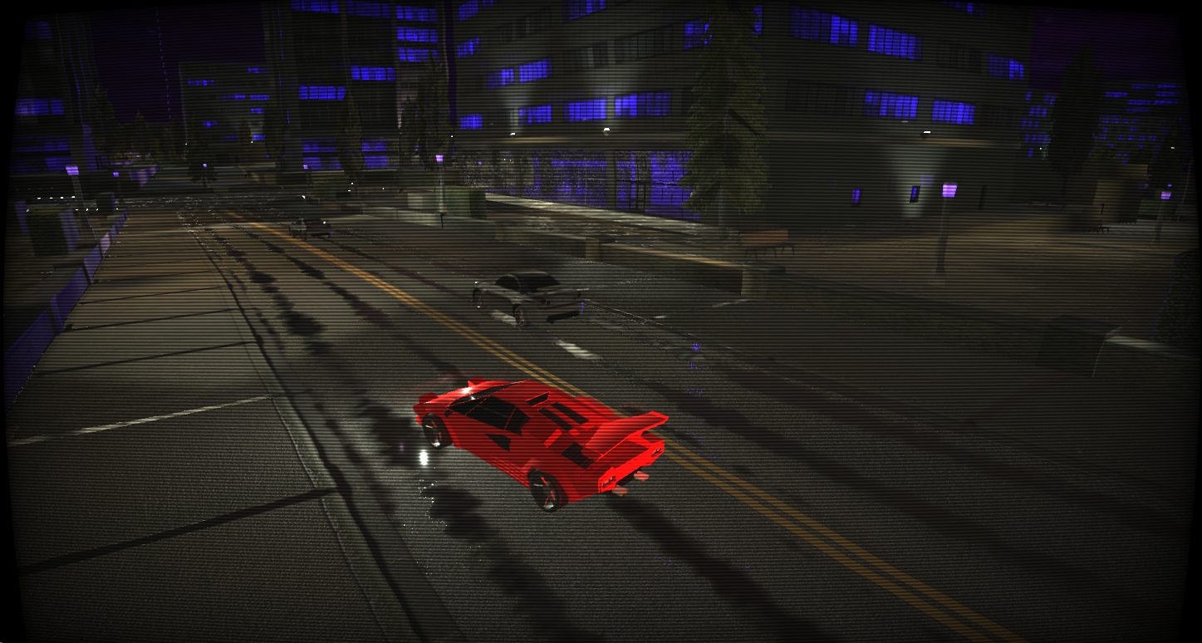

**SketchFab 3d model credits**:

Fifth Element- Police Hover Car ([Sketchfab](https://sketchfab.com/3d-models/fifth-element-police-hover-car-43819752da2e4346a8696f4e8802a1f7))

Low Poly Countach ([Low Poly Lamborghini Countach - Download Free 3D model by 3DShinobi (@3DShinobi) [c9b28a4] (sketchfab.com)](https://sketchfab.com/3d-models/low-poly-lamborghini-countach-c9b28a4ad5c74649a09afa613dd3fae1))

Delorean dmc12 ([Sketchfab](https://sketchfab.com/3d-models/delorean-dmc-12-9112d08f17e746d5a49c89aef367e697))

Cyberpunk Ghetto delorean([Cyberpunk ghetto DeLorean - Download Free 3D model by senya.frozenov (@senya.frozenov) [6455952] (sketchfab.com)](https://sketchfab.com/3d-models/cyberpunk-ghetto-delorean-6455952d4f884b83a8d22877f9aba213))

Neon signs([Neon Signs - Download Free 3D model by Shalmon (@nashalanandas) [307e887] (sketchfab.com)](https://sketchfab.com/3d-models/neon-signs-307e887d740649f88fbc77b061f3a742))  
Garage Scene([Garage Scene - Download Free 3D model by cbrown70 (@cbrown70) [ac81af6] (sketchfab.com)](https://sketchfab.com/3d-models/garage-scene-ac81af69627d4428af4cf05dbdb197fe))

Garage ([Garage - Download Free 3D model by tiunov.se (@tiunov.se) [2b84ff4] (sketchfab.com)](https://sketchfab.com/3d-models/garage-2b84ff408bd347a8a6d05e51b01aa84c))

**Unity Store Assets Credits:**

Demo City By Versatile studios ([Demo City By Versatile Studio (Mobile Friendly) | 3D Urban | Unity Asset Store](https://assetstore.unity.com/packages/3d/environments/urban/demo-city-by-versatile-studio-mobile-friendly-269772)) (FREE)

Arcade Car Controller (Lite) ([Arcade Car Controller (Lite version) | Systems | Unity Asset Store](https://assetstore.unity.com/packages/templates/systems/arcade-car-controller-lite-version-145489))

(FREE)

All these assets were obtained legitimately through legal means and free of cost.

**Copyright Free Songs Used:**

Seeking By Karl Casey

Vintage By Karl Casey

Countach By Karl Casey  
Galaxy By Karl Casey  
Neon Breeze By Karl Casey